

**ERP SYSTEM**

**SOFTWARE ARCHITECTURE DEVELOPMENT**

**TEAM MEMBERS**

Anusha Nagaraj: 11009086  
Vinay Kumar: 11009163  
ShunmugaPrabhuSiddharthan: 11008805  
SachinBarala Ramesh: 11009136  
Manoj Kumar Ellur: 11009115

**GIT LINK**:- https://github.com/yanivc89/ERPSystem

Table of Contents

1. PROJECT OVERVIEW 4

1.1. INTRODUCTION 4

1.2. OBJECTIVES 5

1.3. PURPOSE 5

2. PERSONAS 5

2.1. PERSONA-1 5

2.2. PERSONA-2 6

2.3. PERSONA-3 6

3. ITERATION-1 7

4. INTERVIEWS 8

4.1. INTERVIEW QUESTIONS 8

Purchase Order Management 8

Stock Management 8

Billing 9

Miscellaneous 9

4.2. INTERVIEW RESPONSE 10

4.3. RESPONSE ANALYSIS 15

5. USER STORIES 17

5.1. USER STORY 1 18

5.2. USER STORY 2 18

5.3. USER STORY 3 19

6. STORY BOARD 20

6.1. PROCESS FLOW 20

6.2. LOGISTICS 21

7. DECOMPOSITION DESCRIPTION 23

7.1. USE CASE DIAGRAM 23

7.2. DATA FLOW DIAGRAM 24

8. PROTOTYPING 27

8.1. LOW FIDELITY PROTOTYPE 27

8.2. HIGH FIDELITY PROTOTYPING 35

9. EXPERIENCE MAP 44

10. USER TEST 49

10.1.TEST 49

10.2. ITERATION 2 56

11. TECHNOLOGY 66

12. VISION AND MISSION 67

13. USER STORY TO TASK MAPPING 67

14. WORKLOAD DOCUMENTATION 69

15. REFERENCES 70

# PROJECT OVERVIEW

With the increased difficulties in industries to integrate their business units, ERP serves as a central solution. ERP systems are the systems that support various functions across different business units.

In this project, we are developing an ERP system for retail stores. The users are the Data entry, Purchase department, Goods receiving department, Billing department and the Sales department. The goal of this project is to provide a single system that can serve different department needs and automatic updates that reduces manual effort.

The solution developed incorporates functions such as Billing, user management, stock management, authentication and approvals, report generation, purchase and acknowledgement. The system also automates the business process by continuously synchronizing and automatically updating changes across business units. This application can benefit the retail stores to integrated business processes and to better organize their work.

## INTRODUCTION

In present day, the number of retail shops is increasing with increase in demand for the retail industry. Also, the growth in technology is changing the way business is done. One such technological development is an ERP system. An ERP system is a single platform that integrates and supports functionalities across business units.

A retail store has different operational units performing its own functionalities. This application, is focused on the following units: Stock management, Billing and Purchase management.

The application's primarily focuses on integrating and enhancing communication between different departments like: Purchase, Sales, Billing and Stock.

As the business units rely on the same information for their target needs, the primary feature of this application is a shared database that can support different business units. The key functionalities of the application include create, view, update or delete data related to Dealers, Products, Stores, GRN (Goods Received Note), Bills and Purchase Orders.

## OBJECTIVES

The key objectives of The ERP application are as follows:

* To integrate different business units.
* To impart better communication between different business units.
* To implement synchronization and automatic updates.
* To reduce manual efforts.
* To implement an Effective business process.

## PURPOSE

This software Application is developed to support retailers to accomplish smarter, well organized and well connected business units and to minimize the manual effort and time.

# PERSONAS

This section consists of fictional characters created to represent the targeted audience or a user scenario. Personas are created based on the present real time scenarios to get a better understanding of the requirements or challenges faced by the target audience.  
 The target audiences for our project are the retail stores. The personas for this project are developed based on our research on the retail stores, operating process, organization, technologies, logistics and other relevant data.

Below are three personas considered to describe the possible issues or requirements of retail stores.

## PERSONA-1

**"The Techtronics"** is a small sized retail store. It sells Home appliances, Computer and accessories, Audio and accessories and other Electronic gadgets. Although a small sized store, "The Techtronics" is fast growing and getting popular for its quality products. They are planning to expand the store by increasing the range of products and size of the store"

**Details: -**

They use receipts for billing products. They keep track of the available stocks by comparing the Billing reports, Available stocks count (manually done every week) and the ordered product information (From the purchase department). With a plan of improving the business and expanding the size of store and range of products, The Techtronics feels that they should incorporate a software billing system as the storage of paper bills for substantial number of products is not the best option.

## PERSONA-2

**"Farm Fresh"** is a supermarket selling wide variety of food, groceries and household items. It is well established and has its branches in different locations. It has several dealers supplying goods from different manufacturers and they are sold to the customers in the supermarket.

**Details: -**

The supermarket purchases various categories of products (various brands of products in each category) from different dealers. To purchase products from the dealers, the purchase manager/ salesman prepares a purchase order gets it approved by purchase approver and sends it to the dealer via telephone/fax or Emails. As the purchase management is done on excel sheets and telephones, it is becoming hard for the purchase department to coordinate and keep track of the purchase orders as "Which all purchase order has been ordered? and which all have to be ordered yet? or which all have to be approved for the order to be placed to dealers?".

## PERSONA-3

"**Queens**" is a retail store that sells apparels, accessories and gifts. They have stores developing in major cities like Berlin, Munich and Stuttgart. They sell most of the popular brand of products and the growth rate is increasing every year. "

**Details: -**

Queens is awell-established store and they are planning to improve theirprocess by having a well-defined and organized software infrastructure and systems to manage the business end to end. They want a solution to be developed that can help them improve the stock management.

# ITERATION-1

This section consists of the personas and the first iteration of proposed solution.

**PERSONA 1: -**

"**The Techtronics"** uses receipts for billing products. They keep track of the available stocks by comparing the Billing reports, Available stocks count (manually done every week) and the ordered stocks information (From the purchase department). With a plan of improving the business and expanding the size of store and range of products, The Techtronics feels that they should incorporate a software billing system as the storage of paper bills for large number of products/sale is not the best option.

**Solution**: -  
Software that can do the following

* Generate bills for the products purchased.
* Print the bill.
* Store the bills for viewing later.

**PERSONA 2: -**

**"Farm Fresh"** supermarket purchases different categories of products (various brands of products in each category) from different dealers. To purchase products from the dealers, the purchase manager/ salesman prepares a purchase order gets it approved by purchase approver and sends it to the dealer via telephone/fax or Emails. As the purchase management is done on excel sheets and telephones, it is becoming hard for the purchase department to coordinate and keep track of the purchase orders as "Which all purchase order have been ordered? and which all have to be ordered yet? or which all have to be approved for the order to be placed to dealers?".

**Solution: -**

Software that can do the following

* Authorized person (Purchase manager, purchase order approver or the sales man) should be able to generate, view or edit a purchase order.
* The approver should be able approve or reject the created purchase order.

**PERSONA 3: -**

"**Queens**" is a well-established store and they are planning to improve their process by having a well-defined and organized software infrastructure and systems to manage the business end to end. They want a solution to be developed that can help them improve the stock management.

**Solution: -**

Software that can do the following

* Generate a Goods Received Note for the purchase order.
* Update the Purchase order delivery status depending on all the goods in PO are delivered or only some.
* Automatic increase in the number of available stocks.

# INTERVIEWS

This section contains the details of interviews conducted. We conducted interviews by getting the form with Questionnaires filled by the small sized, midsized and large sized retail stores. The response was studied, analyzed and the analysis graph was generated to understand the present scenarioof the retail stores and to come up with solution that can improve our application.

## INTERVIEW QUESTIONS

The below interview questions were formulated in such a way that, the response will assist us in understanding and analysing the present status of retail stores, organization of the stores, the process followed and how it operates?   
Below are the questions divided intosections that helps us to examine and understand the challenges faced by different sectors in a retail store.

### Purchase Order Management

* How is the Purchase order placed to the dealers?
* How frequently do you order the products from dealers?
* Can a salesman create purchase order?
* How do you place the product order to dealers?

### Stock Management

* How do you maintain store stocks?
* When count of available stocks gets reduced, how do you get to know?
* How do you check/document and acknowledge the received goods from dealers (e.g.: - "We had ordered 10 products and we have received 10 products”)?
* How do you document the received goods from dealers?

### Billing

* How are new product added to the billing system?
* How frequently you use the billing reports from the billing system?

### Miscellaneous

* Where are the dealers and their product details maintained?
* Who decides on which new product to be added to the shop?
* How are products/goods delivered to stores?
* How many Departments are there in your shops/stores? Name them
* How many employees are in each department/division
* How do you check if the stock's expiry date has crossed?

## INTERVIEW RESPONSE

This section contains the response to the above interview questions.

**INTERVIEW 1**

Vorname: - Nachname: -

Geschäftname: **GRUNE KREBS** E-mail: -

Telefonnummer: -

**QUESTIONS: -**

1How do you maintain store stocks?

* Written on paper/book

2) When count of available stocks gets reduced, how do you get to know?

* Manual count is taken

3**)** How do you place the product order to dealers?

* Telefonisch

4) Where are the dealers and their product details maintained?

* Excel sheet

5) How do you check/document and acknowledge the received goods from dealers (eg:- "We had ordered for 10 products and we have got 10 products")

* Written on paper/book

6) How do you document the received goods from dealers?

* Written on paper/book
* Excel Sheet

7) How is the Purchase order placed to the dealers

* Telephone

8) Who decides on which new product to be added to the shop?

* Geschaftsfuhrer und Store Manager

9) How are new product is added to the billing system

* With Software

10) How are products/goods delivered to stores?

* Transport companies

11) How many Departments are there in your shops/stores? Name them

* 2 Abteilungen

12) How many employees are in each department/division

* verschieden

13) How frequently do you order the products from dealers

* Weekly

14**)** How do you check if the stock's expiry date has crossed

* Manually

15) How frequently you use the billing reports from the billing system

* Weekly

16) Can a salesman create purchase order?

* Yes

**INTERVIEW 2**

**Vorname:**Werner **Nachname:**bullre

**Geschäftname:** “eye and art GmbH”  **E-mail:** info@eye-and-art.de

**Telefonnummer:**06221-183394

**QUESTIONS: -**

1How do you maintain store stocks?

* With Software

2) When count of available stocks gets reduced, how do you get to know?

* Manual count is taken
* With software

3**)** How do you place the product order to dealers?

* With software
* Web+Fax+Tel

4) Where are the dealers and their product details maintained?

* With Software

5) How do you check/document and acknowledge the received goods from dealers (eg:- "We had ordered for 10 products and we have got 10 products")

* Written on paper/book
* With software

6) How do you document the received goods from dealers?

* With Software
* Written on paper/book

7) How is the Purchase order placed to the dealers

* Via Email
* Telephone
* With software
* **Händlernimmt den bestellung**

8) Who decides on which new product to be added to the shop?

* Chef mit team

9) How are new product is added to the billing system

* With Software

10) How are products/goods delivered to stores?

* Transport companies

11) How many Departments are there in your shops/stores? Name them

* Kleinst unternehmen verkauf, Buchhaltung

12) How many employees are in each department/divisions

* 9 personenMessungVerkauf, 1 person Beratung+ Buchhaltung

13) How frequently do you order the products from dealers

* Daily

14**)** How do you check if the stock's expiry date has crossed

* Manually
* Esgibtnur 1 product mit

15) How frequently you use the billing reports from the billing system

* Weekly

16) Can a salesman create purchase order?

* Yes

**INTERVIEW 3**

Vorname: **HERMANN** Nachname: **SOCK**

Geschäftname: **HeiselHerrenmode** E-mail: **INFO@HEISEL.COM**

Telefonnummer: **06221-23333**

**QUESTIONS: -**

1How do you maintain store stocks?

* Written on paper/book
* VorbeiBestellung

2) When count of available stocks gets reduced, how do you get to know?

* Ich bin in laden und sehe was Fehlt.

3**)** How do you place the product order to dealers?

* Ich bin im laden und sehe was fehlt

4) Where are the dealers and their product details maintained?

* Ich bin der Händler

5) How do you check/document and acknowledge the received goods from dealers (eg:- "We had ordered for 10 products and we have got 10 products")

* Written on paper/book

6) How do you document the received goods from dealers?

* Not answered

7) How is the Purchase order placed to the dealers

* Via Email
* Fax

8) Who decides on which new product to be added to the shop?

* Ich/ Owner

9) How are new product is added to the billing system

* Kein system zeichnung am produkt

10) How are products/goods delivered to stores?

* Transport companies

11) How many Departments are there in your shops/stores? Name them

* 1

12) How many employees are in each department/division

* All

13) How frequently do you order the products from dealers

Not Answered

14**)** How do you check if the stock's expiry date has crossed

* Manually

15) How frequently you use the billing reports from the billing system

* Depending on situation- sometimes daily

16) Can a salesman create purchase order?

* No

## RESPONSE ANALYSIS

Following are the inference from the above graphical analysis.

* The improvement in software technology has made everyone move to software based billing system.
* The purchase management analysis shows that, many have not started using the software application based approach.
* In stock management, many stores are using software to maintain their stocks. But due to the gap between stock management and purchase management, there is a lot of manual work carried to track the available stocks, because of which available stocks have to be manually counted and updated into the system.
* In delivery Acknowledgement/Documentation, half of the people are using paper and excel based documentation.

# USER STORIES

This section consists of the personas and its proposed solution after analyzing our assumptions and the interview response.

## USER STORY 1

**THE TECHTRONICS: -**

***"*** *We use receipts for billing products. We are planning of improving the business by expanding the size of store and range of products. We feel that storage of paper bills for large number of products is not the best option. Hence, we would like to incorporate a software billing system****."***

**Solution: -**

**Iteration2**

Software that can do the following

* Generate bill for the products sold.
* Print the bill
* Store the bills for viewing later.
* Email bill to the customer.
* Automatic reduction in the number of available stocks when it is billed.

## USER STORY 2

**FARM FRESH: -**

***"****We sell selling wide variety of food, groceries and household items. We are well established and have branches in various locations. Our purchase department has a purchase manager and a purchase approver. The purchase manager/salesman prepares a purchase order gets it approved by purchase approver and sends it to the dealer via telephone/fax and Emails. As the purchase management is done on excel sheets and telephones, it is becoming hard for the purchase department to coordinate and keep track of the purchase orders as "Which all purchase order have been ordered? and which all have to be ordered yet? or which all have to be approved for the order to be placed? We would be glad to know if any software can make this work any easier****".***

**Solution: -**

**Iteration2**

Software that can do the following

* Generate, view or edit a purchase order from the authorized persons (Purchase manager, purchase order approver or the sales man).
* The manager can approve or reject the created purchase order.
* If the PO is approved, it is automatically mailed to the corresponding dealer.
* If the PO is rejected the concerned shop manager is notified of the same.

## USER STORY 3

**QUEENS:-**

***"****We are a retail store selling apparels, accessories and gifts. We are planning to improve our business by incorporating helpful software for better an organization. Primarily, we would like to have a software that can help improve and ease the work of stock management.****"***

**Solution: -**

**Iteration2**

Software that can do the following

* Generate a Goods Received Note for the purchase order.
* Update the Purchase order delivery status depending on all the goods in PO are delivered or only some.
* Email the GRN acknowledgement to dealers.
* Automatic increase in the number of available stocks.
* A Notification to the concerned person when the count of available stock goes below threshold count.
* Export the stock report to excel.

# STORY BOARD

## PROCESS FLOW

The logistics of retail stores is organized in the form of images to form a story for pre-understanding of the system.

## LOGISTICS

The logistics of the application is organized in the form of a flow diagram with the colour coded units for distinguishing between different operational units of the retail store.

**Colour code**: -

Purchase Department **(Retail Store)** Goods Receiving Department**(Retail Store)**

Application feature Retail Store

Dealers Customer

Billing Department (**Retail Store)**

**FLOW DIAGRAM**

NO

**PO APPROVAL: - Approves Purchase Order**

**PO GENERATOR: - Generates Purchase Order**

**PO Approved?**

**AUTOMATION:-  
Notification sent to concerned person regarding the rejection**

YES

**DEALERS: -  
Receives the Purchase order via automated mail**

**GOODS RECEIVING DEPARTMENT:-  
Checks the goods**

**DEALERS: -  
Delivers the ordered products**

**GOODS RECEIVING DEPARTMENT:-  
Generates GRN with Delivery status "Closed"**

**GOODS RECEIVING DEPARTMENT:-  
Generates GRN with Delivery status "Open"**

**All Goods Present?**

**AUTOMATION:  
Automatic increment in the available stocks in database**

NO

YES

**STORE: -  
Display/stores the product for sale**

**AUTOMATION: -  
Automatic reduction in the available stock from database**

**BILLING: - Bills the product and receives the payment**

**CUSTOMER:-  
Adds product into cart**

The below graphical representation shows the user story mapping of the application.

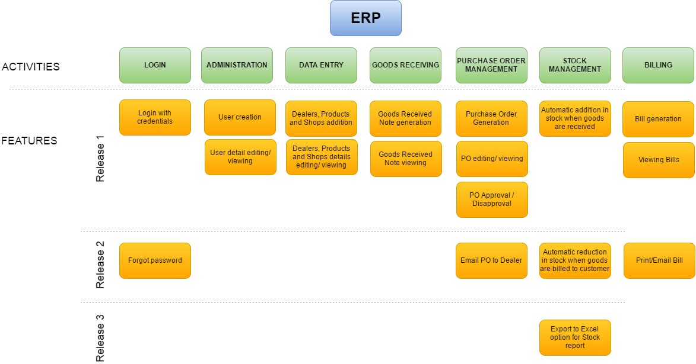

# DECOMPOSITION DESCRIPTION

## USE CASE DIAGRAM

Below is the use case diagram that depicts the behaviour of the application. It consists of the types of user and their corresponding actions that can be performed in the ERP application.

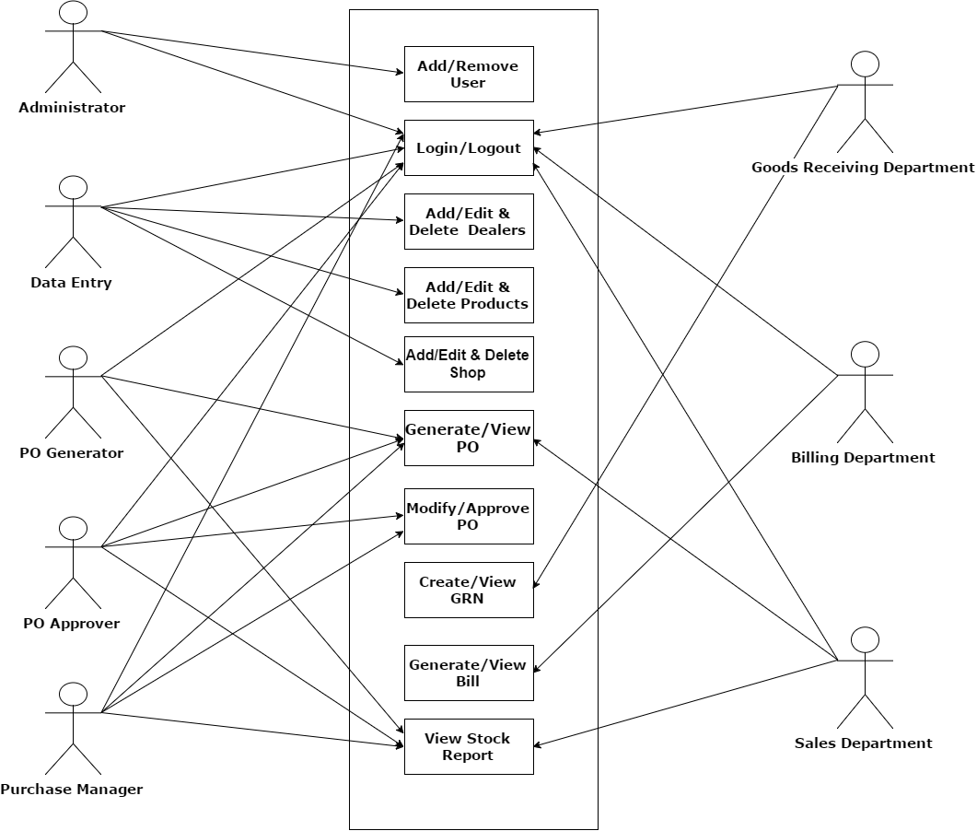

## DATA FLOW DIAGRAM

Below are the dataflow diagrams for better understanding of the all the user actions.

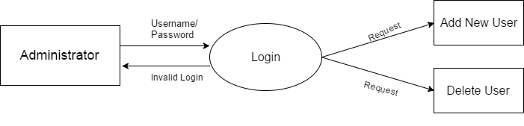

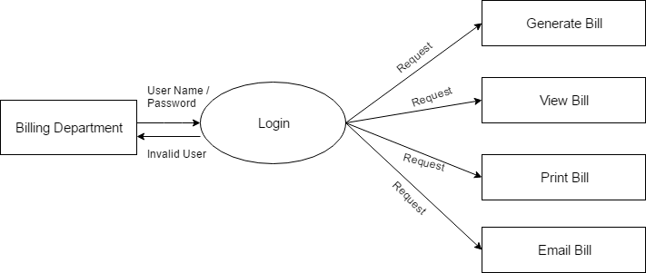

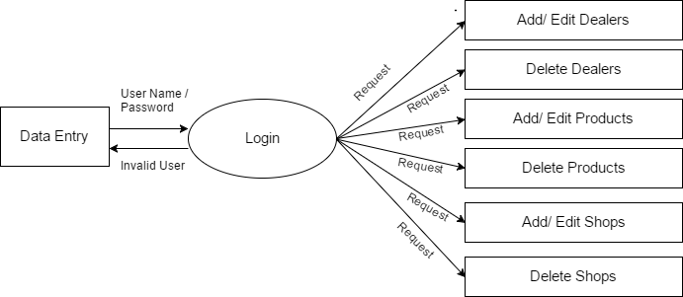

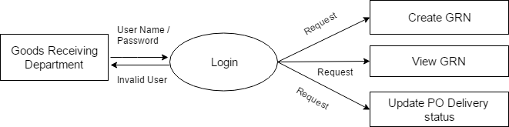

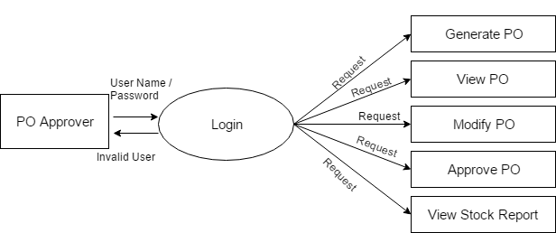

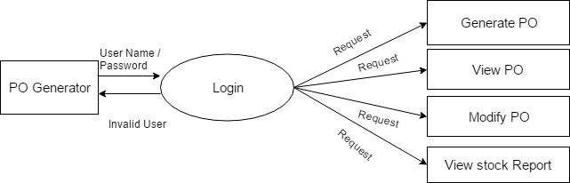

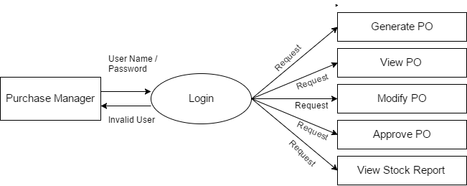

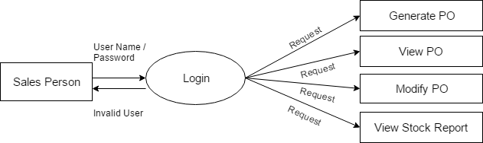

# PROTOTYPING

## LOW FIDELITY PROTOTYPE

This section contains the pencil sketches that represents the screens and characteristics of the final product.

**ADMINISTRATOR:-**

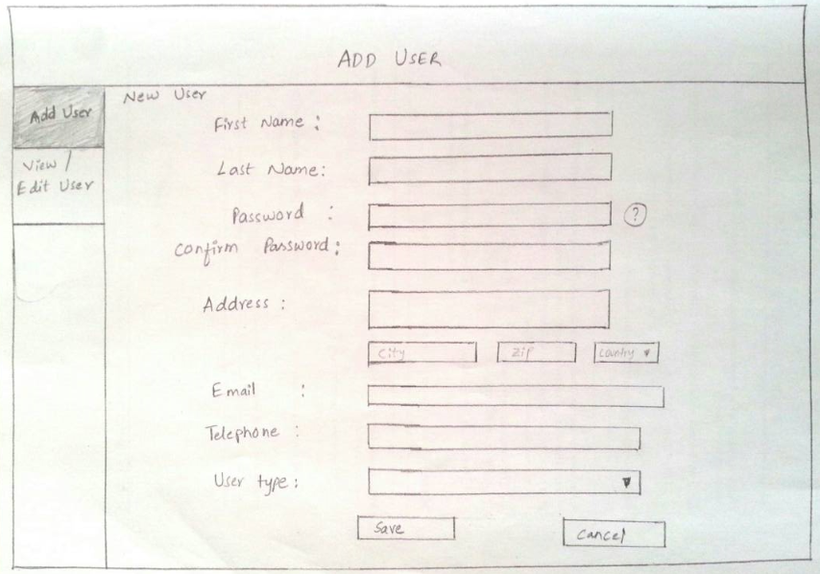

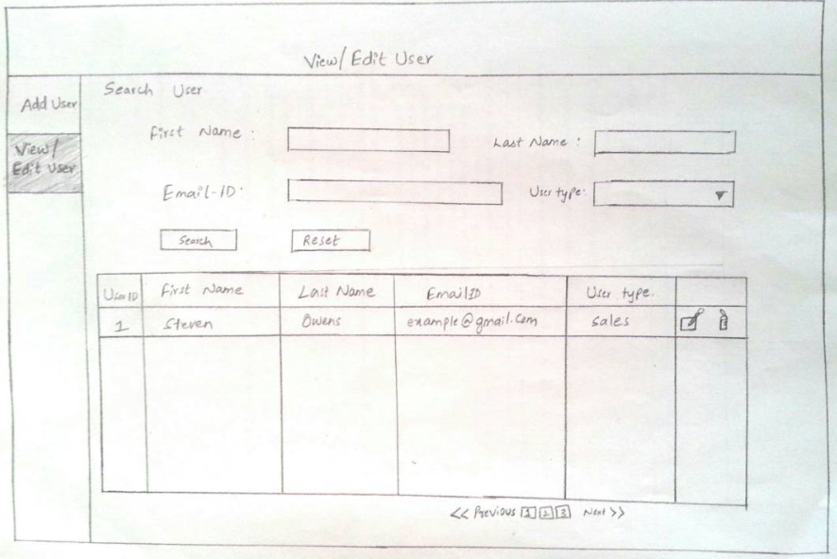

**DATA ENTRY:-**

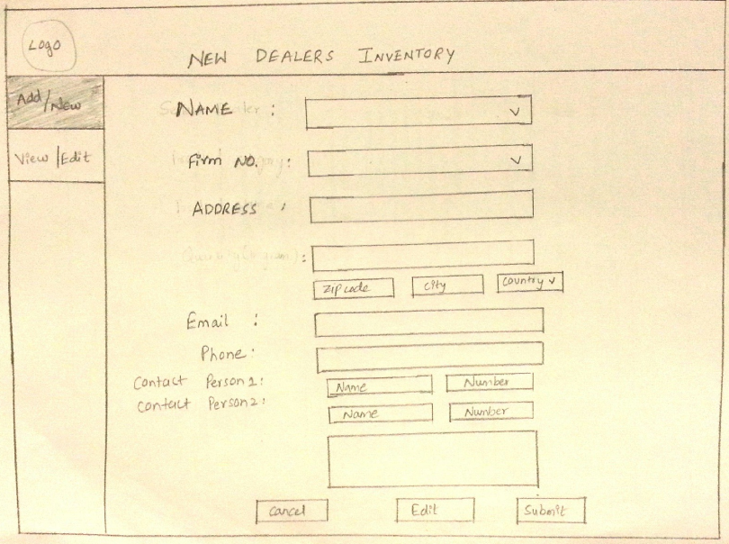

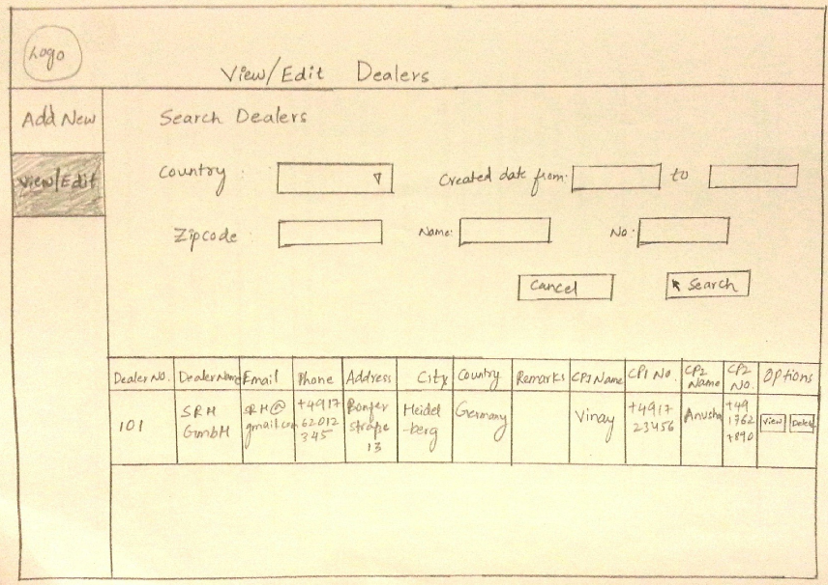

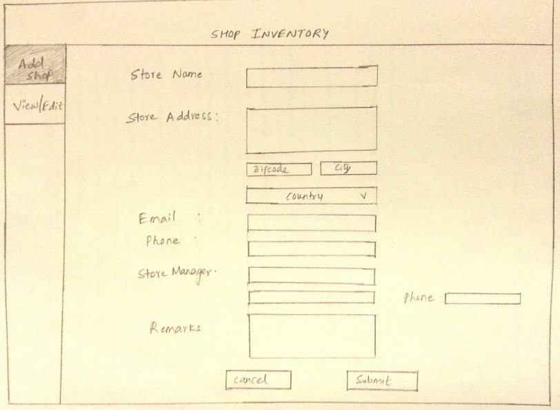

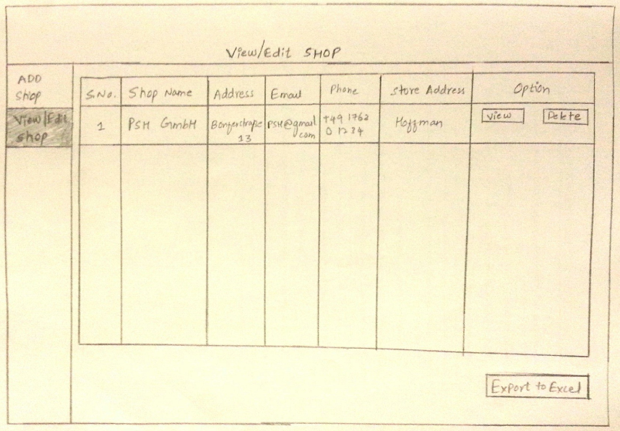

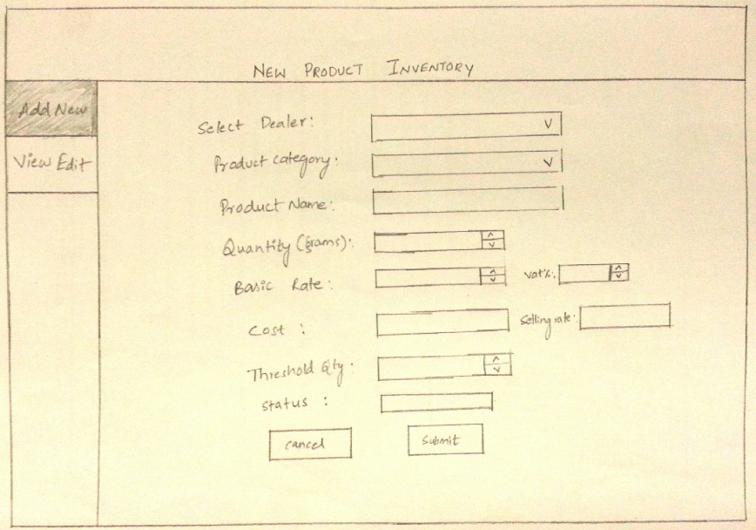

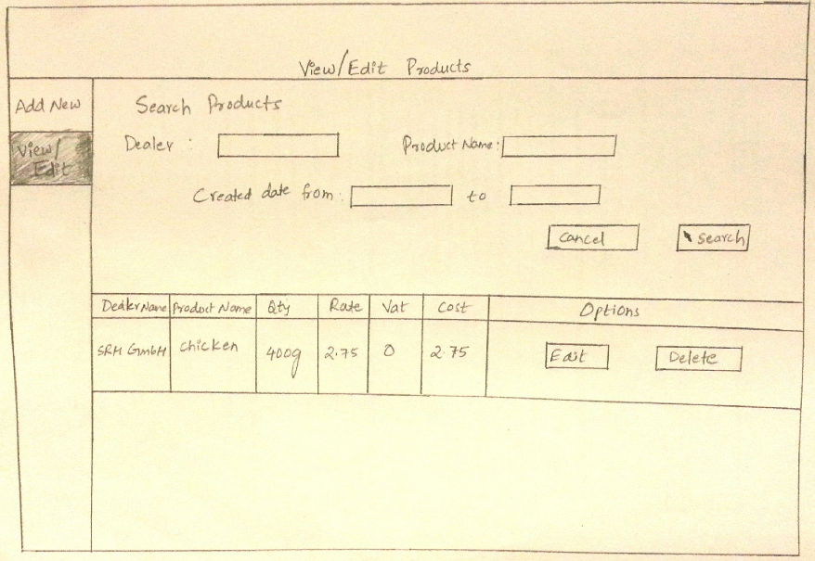

**PURCHASE DEPARTMENT:-**

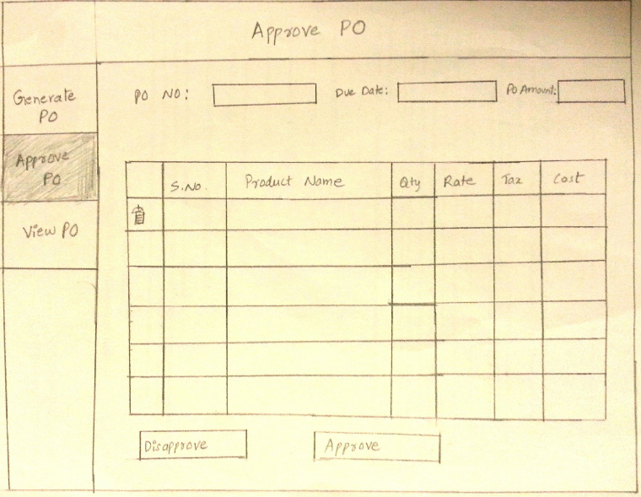

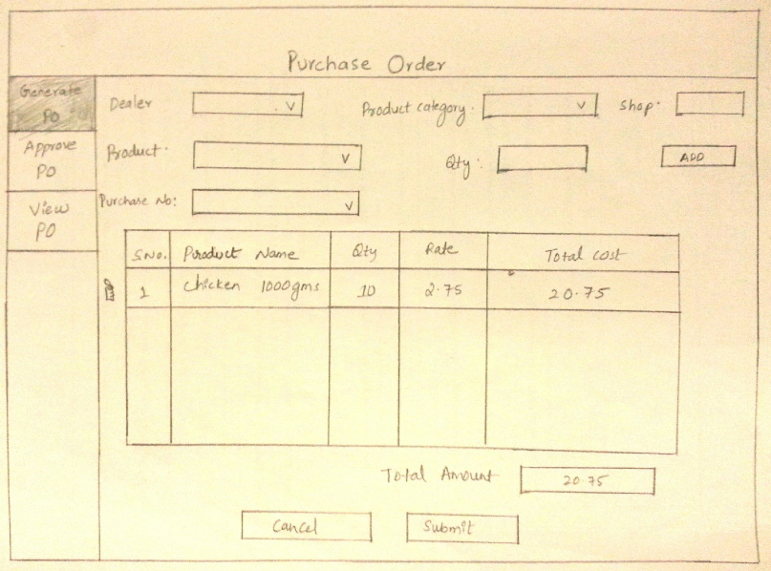

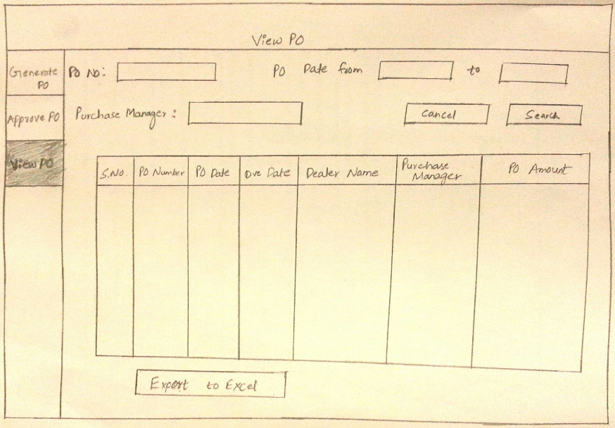

**GOODS RECEIVING DEPARTMENT:-**

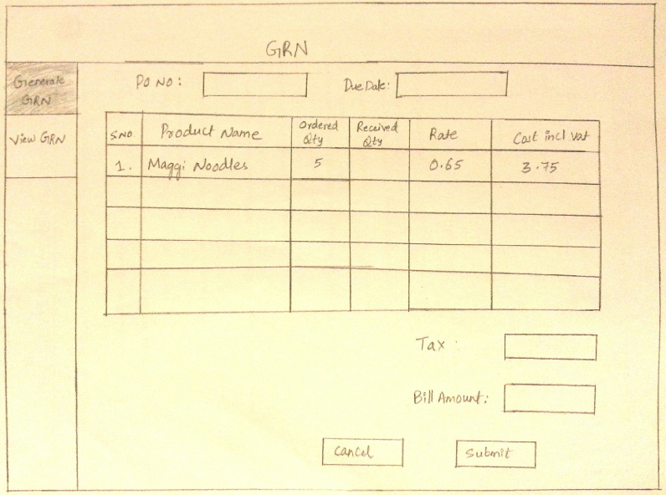

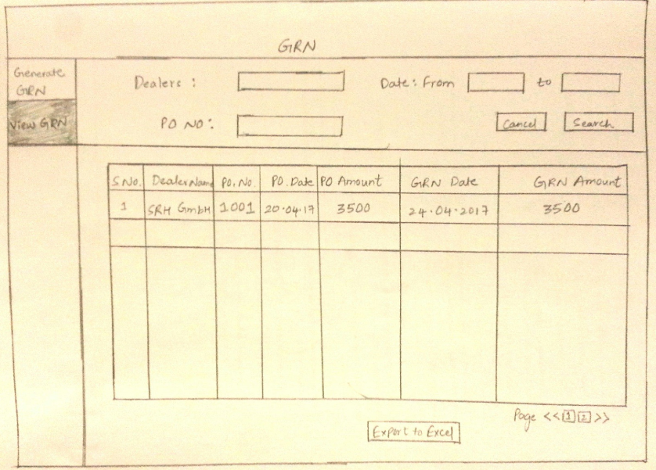

**BILLING DEPARTMENT:-**

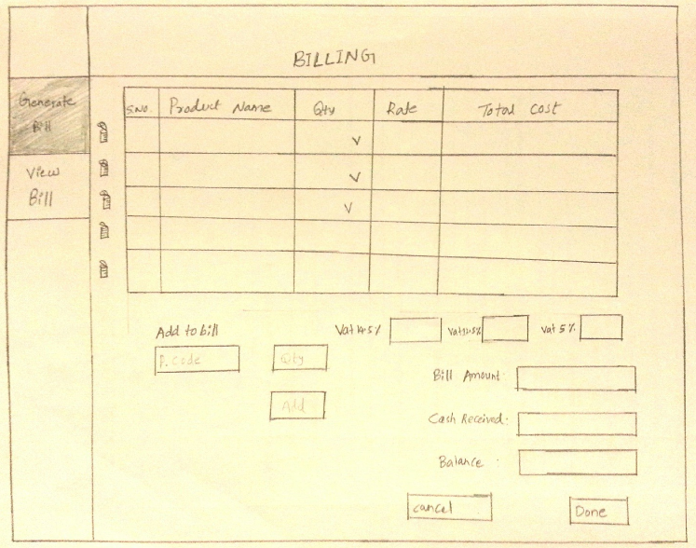

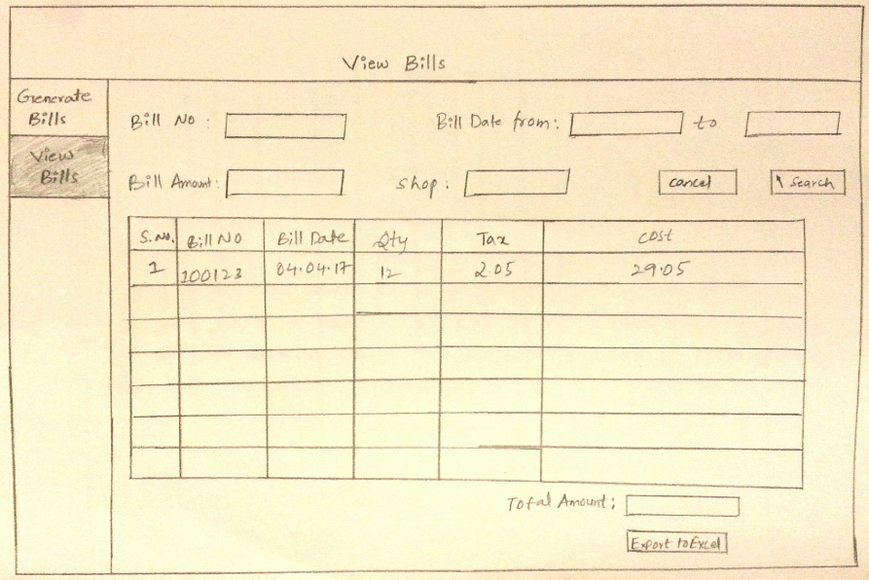

**AUTHORIZED PERSON:-**

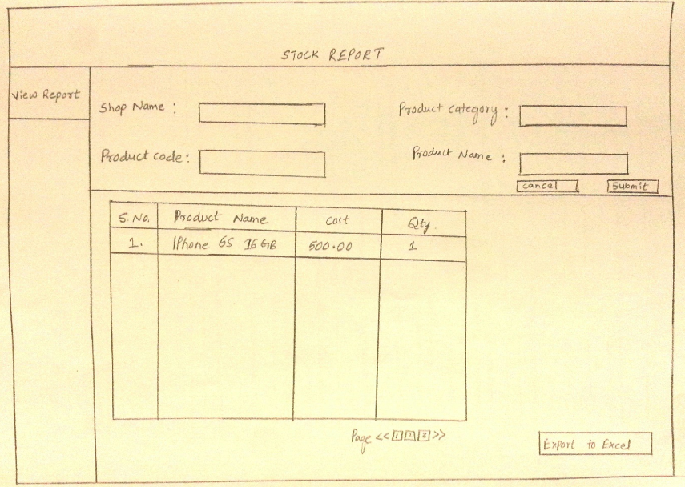

## HIGH FIDELITY PROTOTYPING

This is a prototype with all the required details, features implemented with the help of Low fidelity prototype and looks close to the final product.

**LOGIN SCREEN**

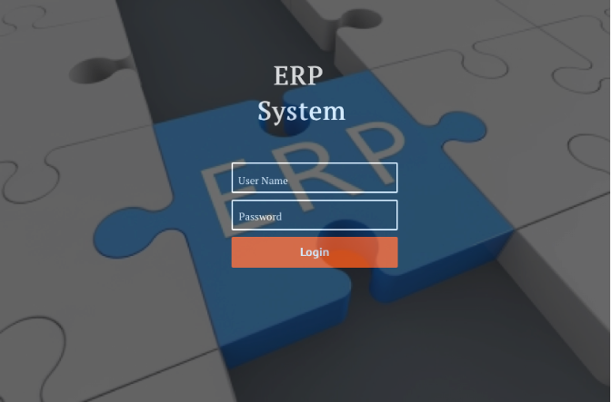

**ADMIN SCREEN**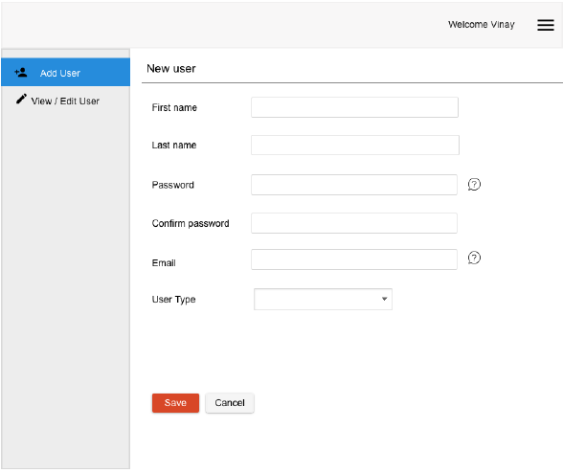

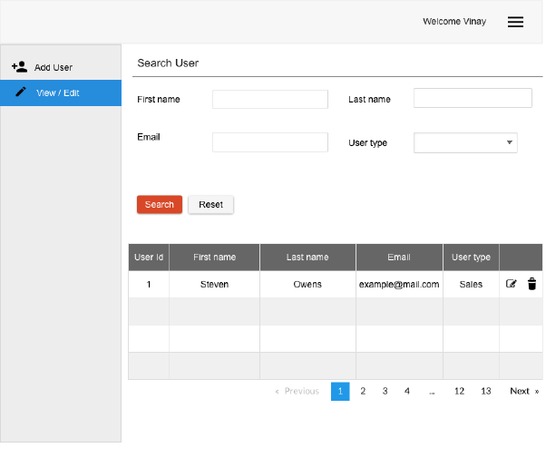

**DATA ENTRY DEPARTMENT**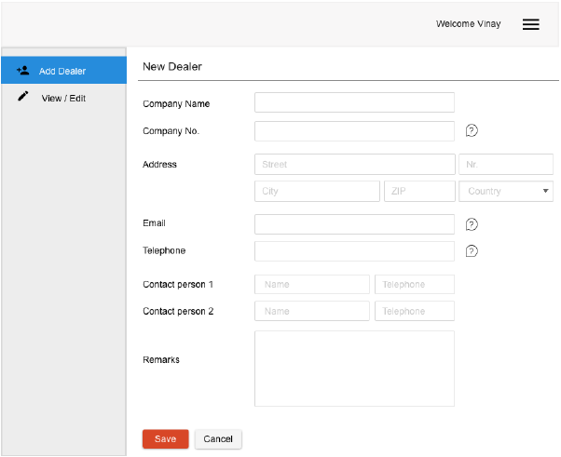

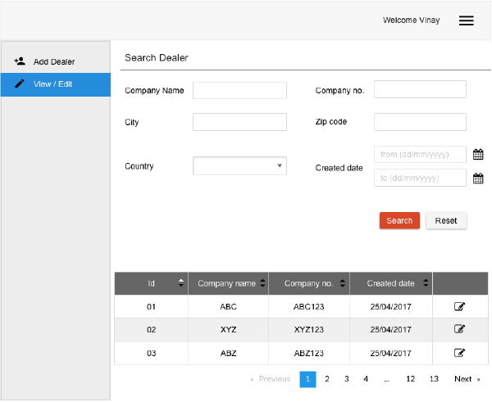

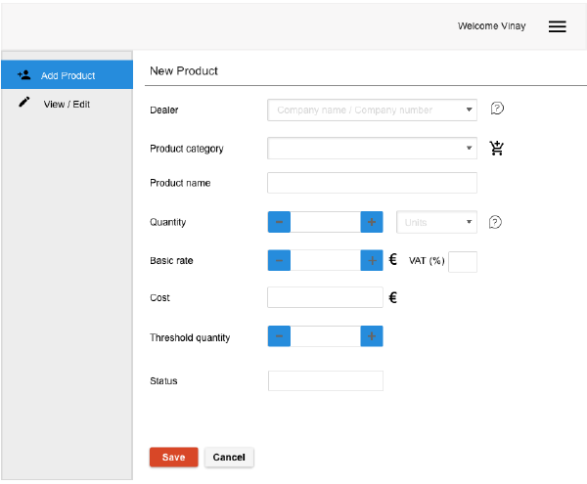

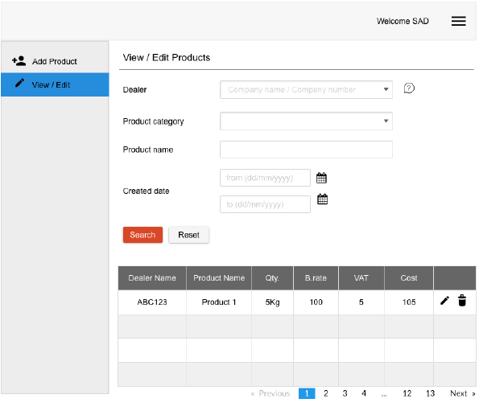

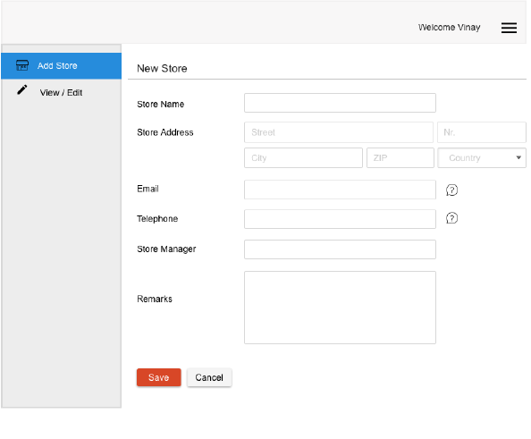

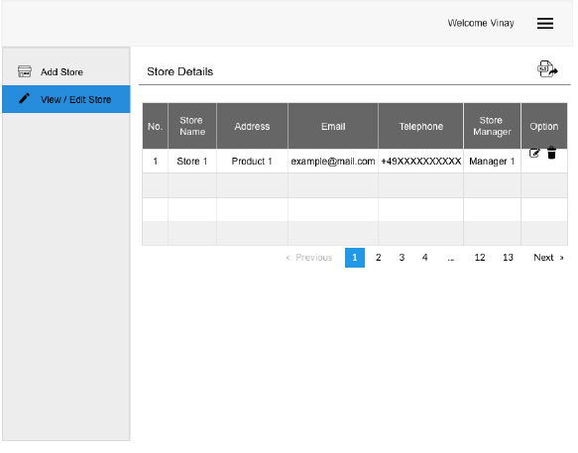

**PURCHASE DEPARTMENT** 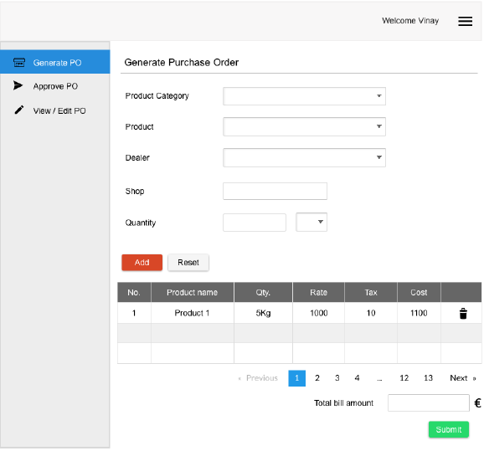

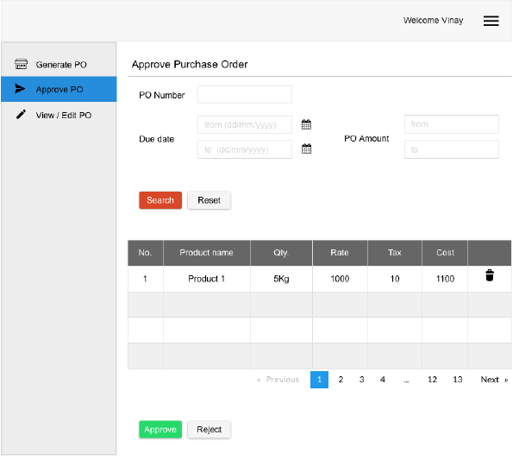

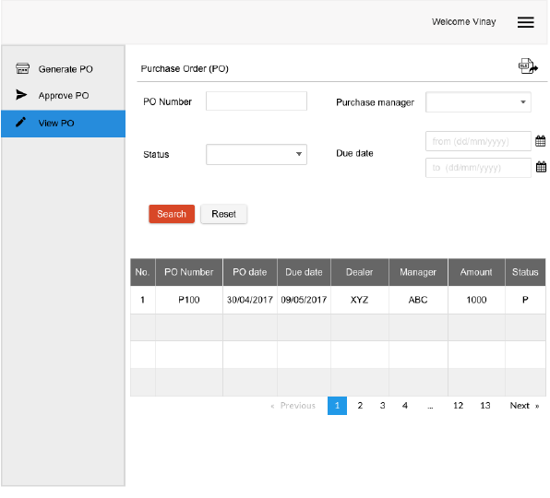

**GOODS RECEIVING DEPARTMENT**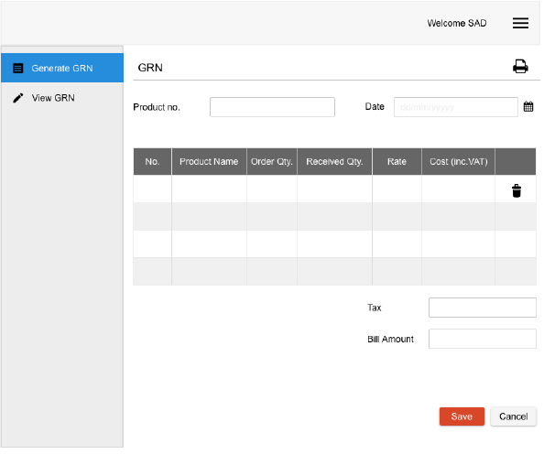

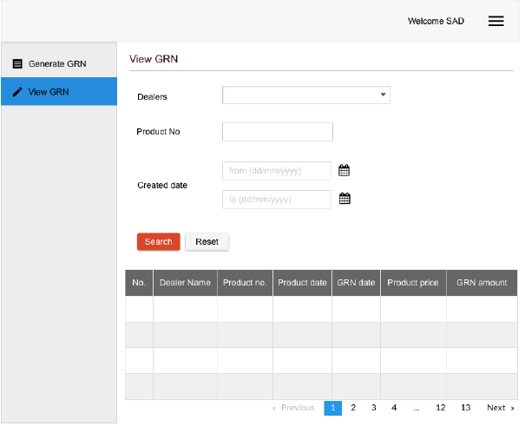

**STOCK REPORT SCREEN**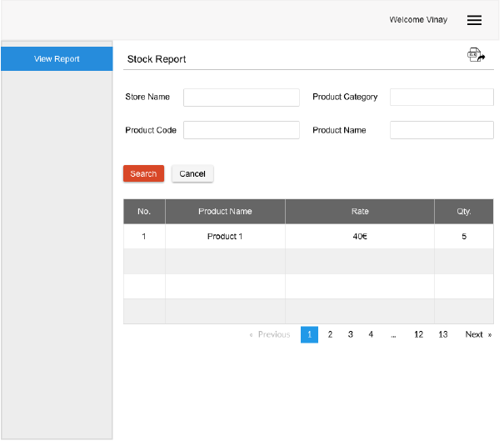

# EXPERIENCE MAP

The below section consists of the customer interactions with the application and their experience when they navigate through the application.

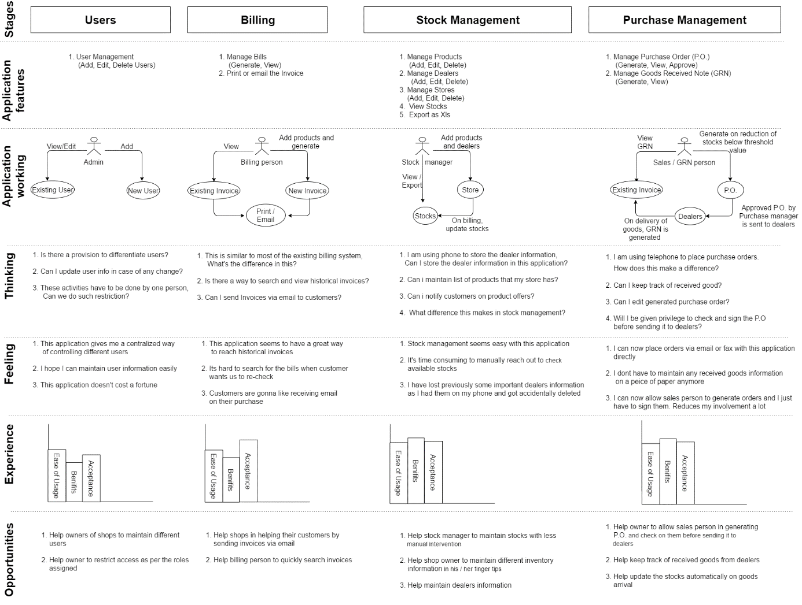

Stage 1: Users

Features: User Management

*Application working:*

The owner of the shop should keep track of employees of his stores. He/she should have all the information about his employees and it should be safe and accessible to designated persons. Also, this information should be easily editable in case of any changes in the employee information such as change in address, phone number etc.

*Thinking: Owner’s thoughts when he thinks of an application*

1. Is there a provision to differentiate users?

2. Can I update user info in case of any change?

3. These activities must be done by one person; can we do such restriction?

*Feeling: Owner’s feelings towards application*

1. This application gives me a centralized way of controlling different users.

2. I hope I can maintain user information easily.

3. This application doesn't cost a fortune.

*Opportunities:*

1. Help owners of shops to maintain different users.

2. Help owner to restrict access as per the roles assigned.

Stage 2: Billing

Features:

1. Manage Bills (Generate, View)

2. Print or email the Invoice

*Application working:*

Billing person expects a straightforward way to search for an invoice that was generated in the past. Also, expects newer way of helping the customers not lose the invoices generated. The application allows user to view the historical invoices by searching with different filters and emailing the invoices to the customers.

*Thinking: Owner’s thoughts when he thinks of an application*

1. This is like most of the existing billing system, What's the difference in this?

2. Is there a way to search and view historical invoices?

3. Can I send Invoices via email to customers?

*Feeling: Owner’s feelings towards application*

1. This application seems to have a great way to reach historical invoices.

2. It’s hard to search for the bills when customer wants us to re-check.

3. Customers are going to like receiving email on their purchase.

*Opportunities:*

1. Help shops in helping their customers by sending invoices via email.

2. Help billing person to quickly search invoices.

Stage 3: Stock Management

Features:

1. Manage Products (Add, Edit, Delete)

2. Manage Dealers (Add, Edit, Delete)

3. Manage Stores (Add, Edit, Delete)

4. View Stocks

5. Export as Xls

*Application working:*

Application lets the concerned person in the store to maintain product information, dealer information, store information etc. It also allows viewing of available stocks and thereby helps take decision based on the stocks availability. The prominent feature of the application is that it reduces the stock as and when the products are sold which in turn gives the easiest way forward to manage stocks.

*Thinking: Owner’s thoughts when he thinks of an application*

1. I am using phone to store the dealer information, Can I store the dealer information in this application?

2. Can I maintain list of products that my store has?

3. Can I notify customers on product offers?

4. What difference this makes in stock management?

*Feeling: Owner’s feelings towards application*

1. Stock management seems easy with this application.

2. It's time consuming to manually reach out to check available stocks.

3. I have lost previously some important dealers information as I had them on my phone and got accidentally deleted.

*Opportunities:*

1. Help stock manager to maintain stocks with less manual intervention.

2. Help shop owner to maintain different inventory information in his / her finger tips.

3. Help maintain dealers’ information.

Stage 4: Purchase Management

Features:

1. Manage Purchase Order (P.O.) (Generate, View, Approve)

2. Manage Goods Received Note (GRN) (Generate, View)

Application working:

Application allows the owner to keep track of Purchase orders and the GRNs. It provides an intelligent way to check and approve the generated P.O. before placing the order with dealers. It helps the store employees in comparing the P.O. and the received goods and generating the GRN on the same if everything seems right.

*Thinking: Owner’s thoughts when he thinks of an application*

1. I am using telephone to place purchase orders. How does this make a difference?

2. Can I keep track of received good?

3. Can I edit generated purchase order?

4. Will I be given privilege to check and sign the P.O. before sending it to dealers?

*Feeling: Owner’s feelings towards application*

1. I can now place orders via email or fax with this application directly.

2. I don’t have to maintain any received goods information on a piece of paper anymore.

3. I can now allow sales person to generate orders and I just should sign them. reduces my involvement a lot.

*Opportunities:*

1. Help owner to allow sales person in generating P.O. and check on them before sending it to dealers.

2. Help keep track of received goods from dealers.

3. Help update the stocks automatically on goods arrival.

# 10. USER TEST

## 10.1.TEST

Users were asked to operate on the app and below is the feedback of the users

**Mark one of the options given below**

1. Login Screen page

I can easily understand the screen. It is self-explanatory.

It is difficult to understand what this screen is for.

It’s totally confusing.

1. Login Screen Color

I like the color contrast. Its smooth on sight.

The color is somewhat flashy.

I dint like the color.

1. Add pages (User, Product, Dealer, Store, GRN, P.O., Bills)

It has got basic necessary fields. Input fields are big enough.

It has not got basic necessary fields. (Mention if any).

Input fields are not big enough.

1. Add pages (User, Product, Dealer, Store, GRN, P.O., Bills)

Input fields are Self Explanatory.

Input fields are hard to understand. (Mention where you observed this).

Input fields are confusing.

Reason: Lack of domain knowledge prompted in selecting option 2 in some cases.

1. Add pages (User, Product, Dealer, Store, GRN, P.O., Bills)

I like the color of buttons used.

Button colors could have been better.

I don’t like the colors on button used.

1. Add pages (User, Product, Dealer, Store, GRN, P.O., Bills)

I like the way input fields are arranged.

All Input fields could have been arranged one below the other.

I dint like the arrangement of Input fields.

1. Add pages (User, Product, Dealer, Store, GRN, P.O., Bills)

I like the placement of buttons.

I felt it could have been on the right side of the screen.

I dint like buttons.

1. View / Edit pages (User, Product, Dealer, Store, GRN, P.O., Stock, Bills)

Search fields are enough.

Search fields are not enough.

No Idea.

1. View / Edit pages (User, Product, Dealer, Store, GRN, P.O., Stock, Bills)

Data table looks good.

Data table could have been better.

I dint like the data table used.

1. View / Edit pages (User, Product, Dealer, Store, GRN, P.O., Stock, Bills)

Icons used inside data table looks great.

Buttons could have been more appropriate.

I dint like the icons inside the data table.

1. Overall Page layout in general

Page layout and use of space looks appropriate.

Page layout could have been better. It looks too simple.

I dint like the Page layout.

1. Right Menu in the Page Header

Looks good and has basic features included.

More features could be added into this menu.

I dint like Menu there.

1. Overall Color combination on the pages

Looks great and simple.

Looks simple.Could have been more colorful.

I dint like the color selection.

**General Comments on any improvement required**

1. *"It looks simple and good. The header looks blank. Needs something there. Logo or something filling."*
2. *"I like the left navigation. It’s easy to know where the user is. Great job!"*
3. *"I would like to see more features included in the Right top menu such as Outlook integrated you know."*
4. *"The page looks too grayish. It would have looked different with different colors."*
5. *"I want to see this fully completed and working."*
6. *"I hope this helps workers in shops to a great extent."*
7. *"The icons looked more of mobile versioned. Can be improved."*
8. *"Google like search would have been great."*
9. "*Slight alignment corrections can be made.*"
10. *"Can’t see forgot password functionality in login page. Need it."*
11. *" Looks great for me. Hope it comes out well once completed."*

## 10.2. ITERATION 2

Keeping in mind the feedback of the users and reexamining the application for more improvements the application screens are updated as below.

**LOGIN SCREEN: -**

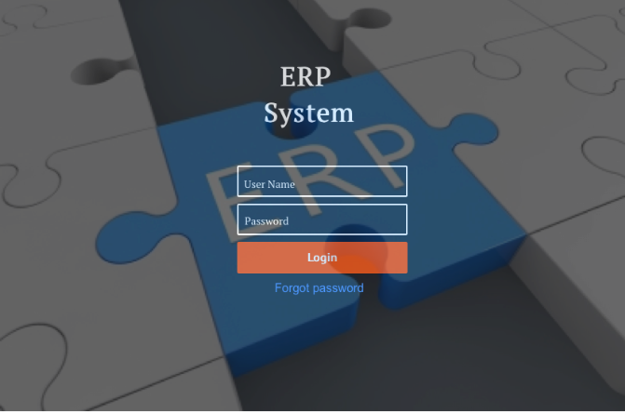

**ADMINISTRATOR SCREENS**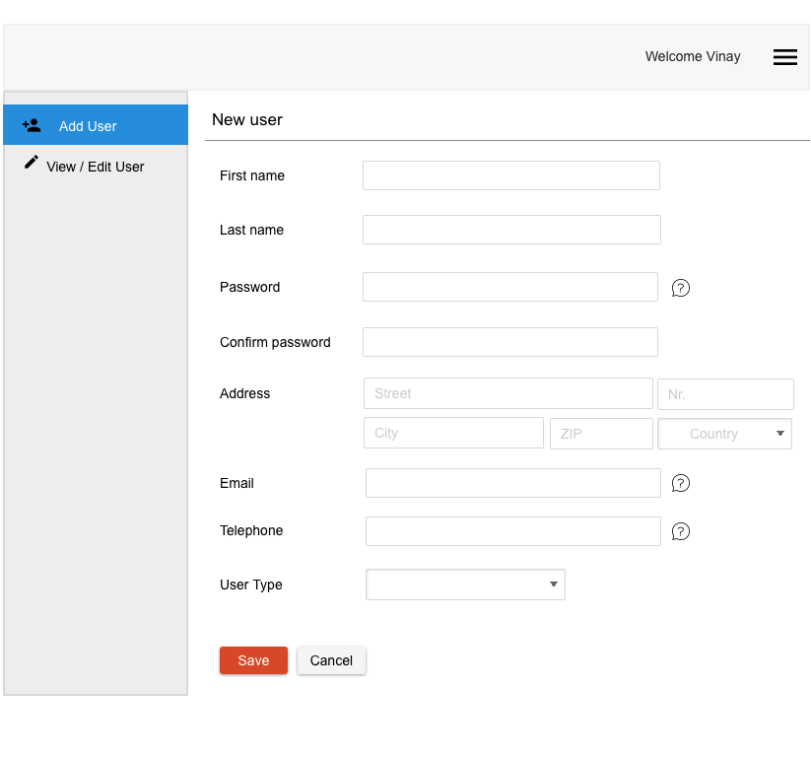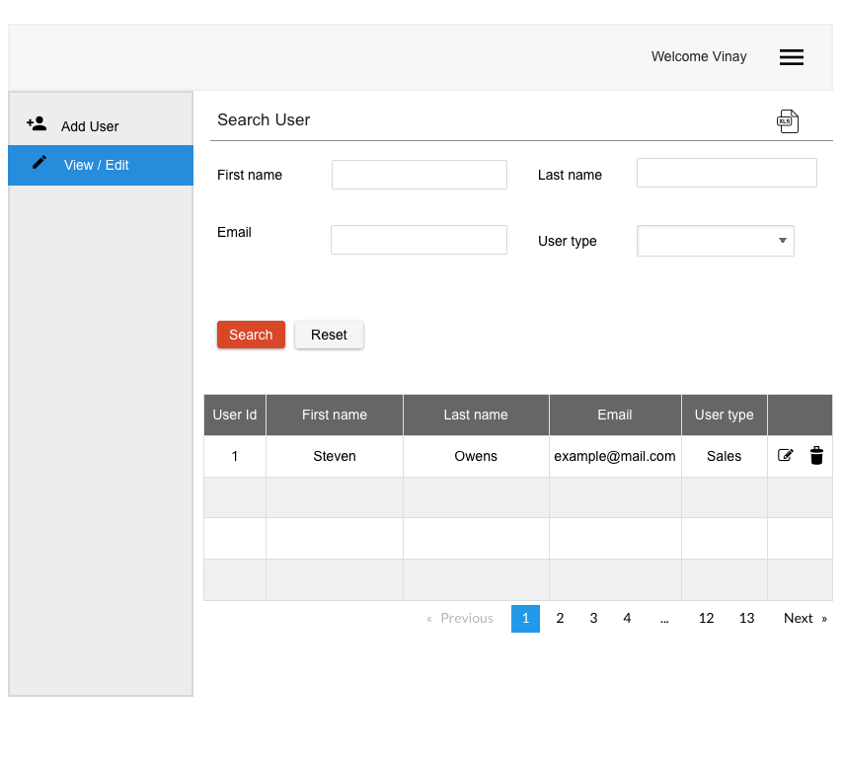

**DATA ENTRY SCREENS**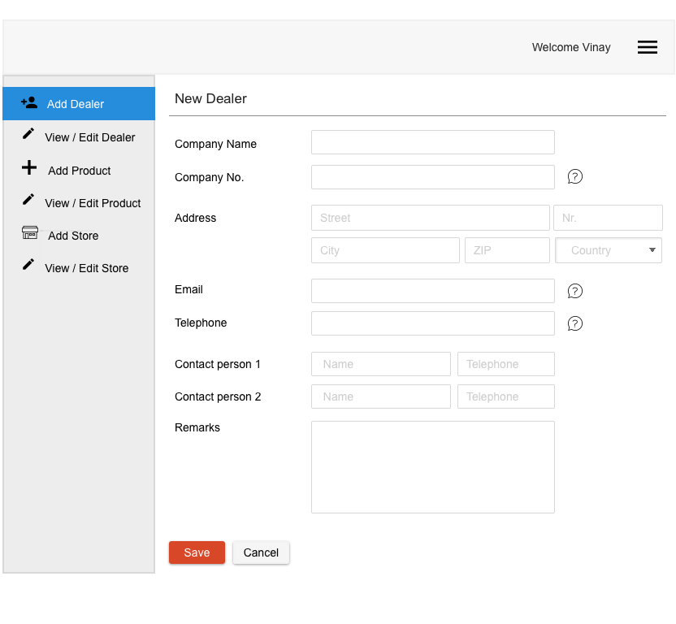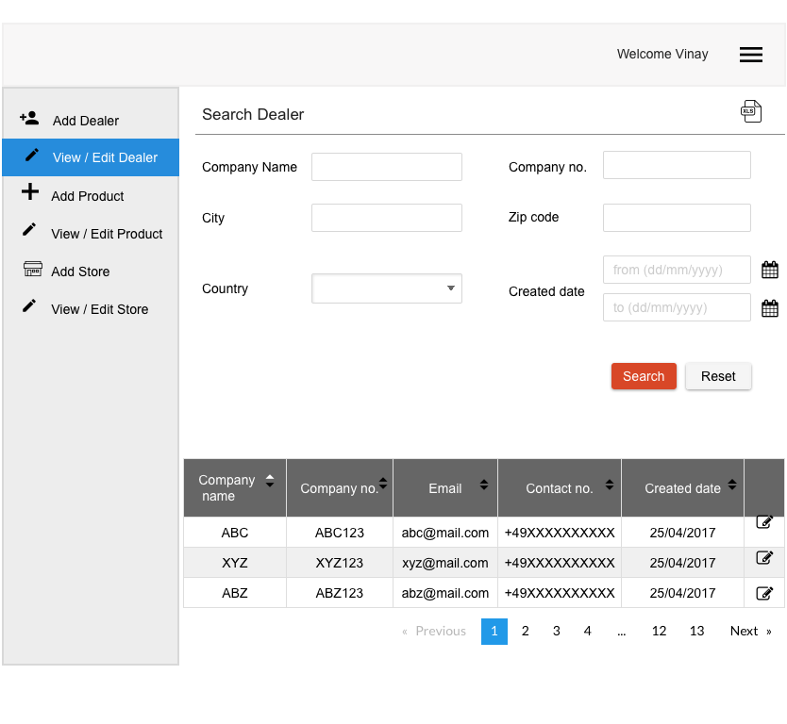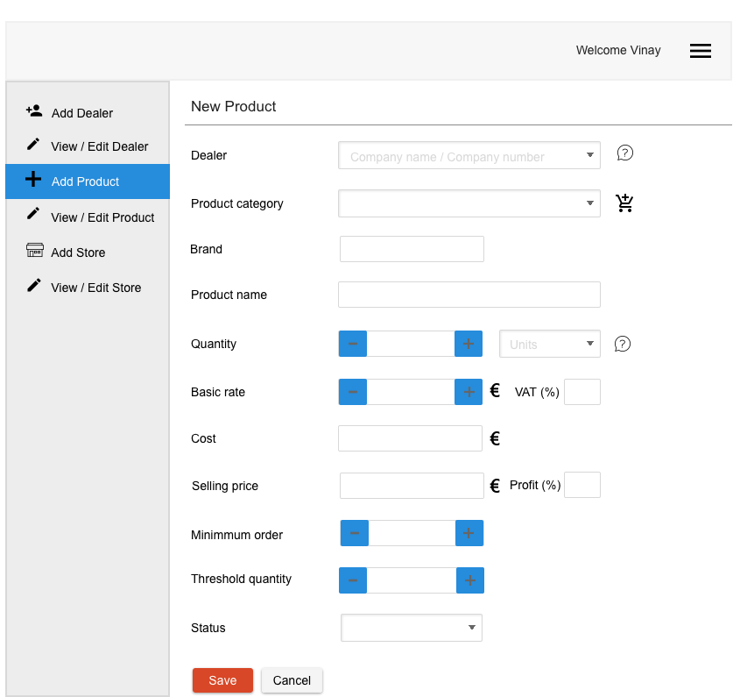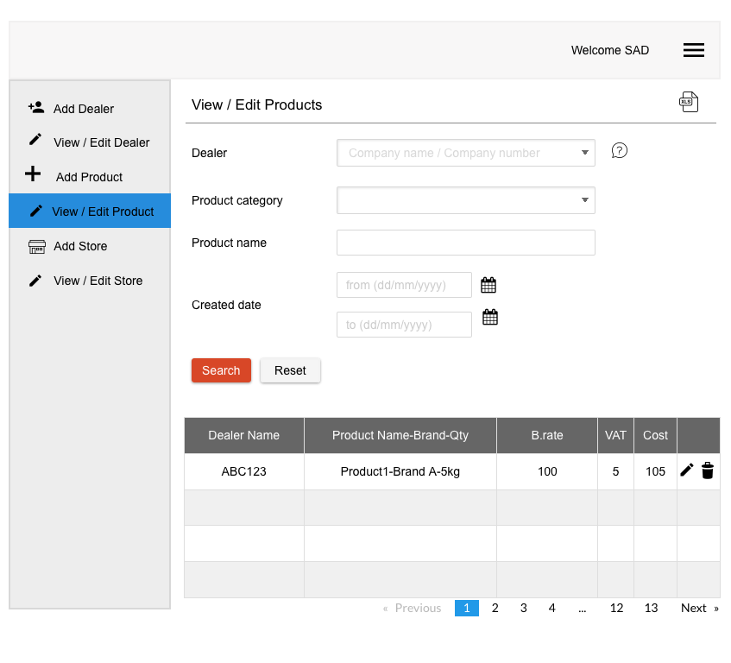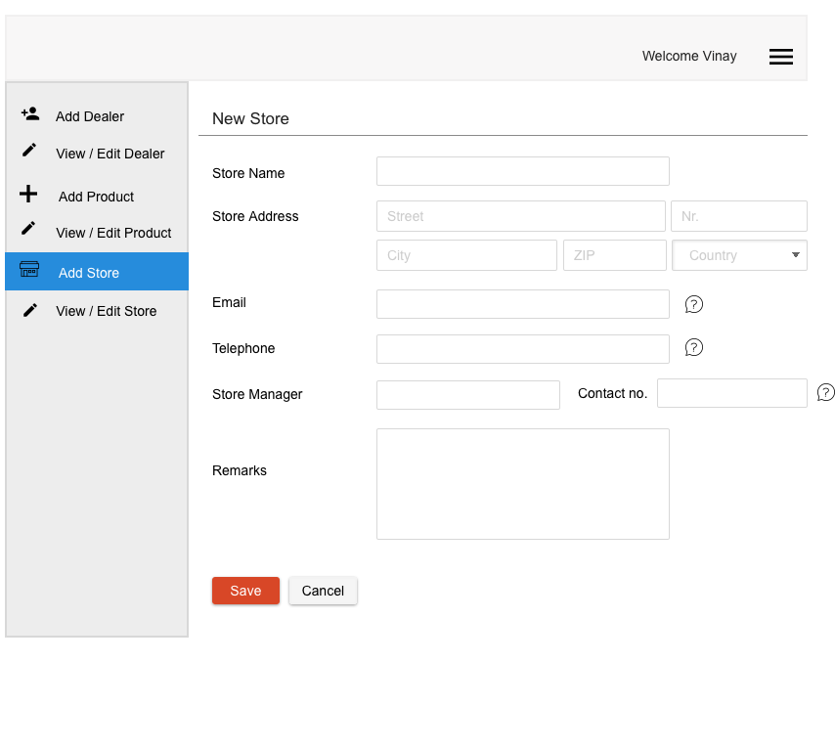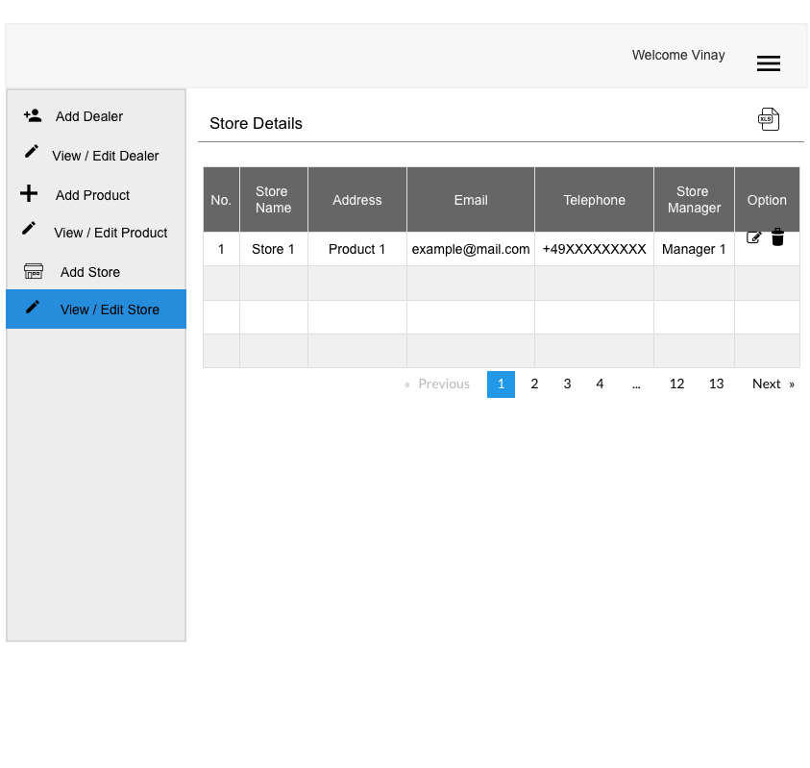

**PURCHASE DEPARTMENT SCREENS**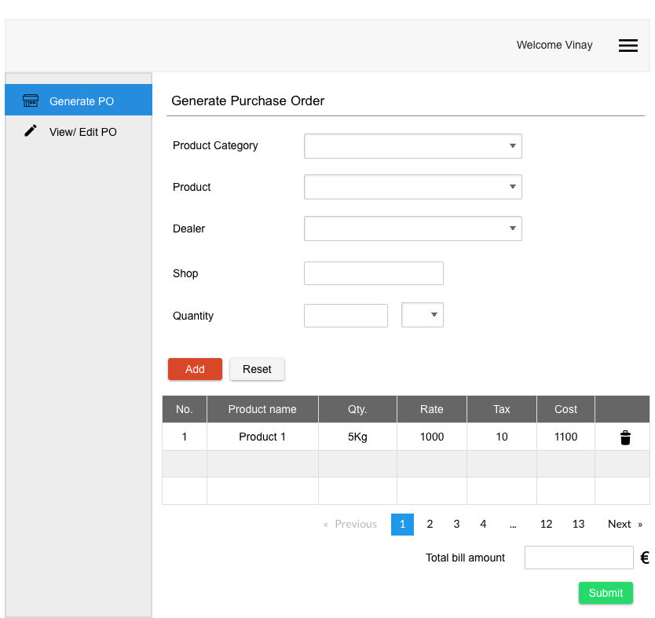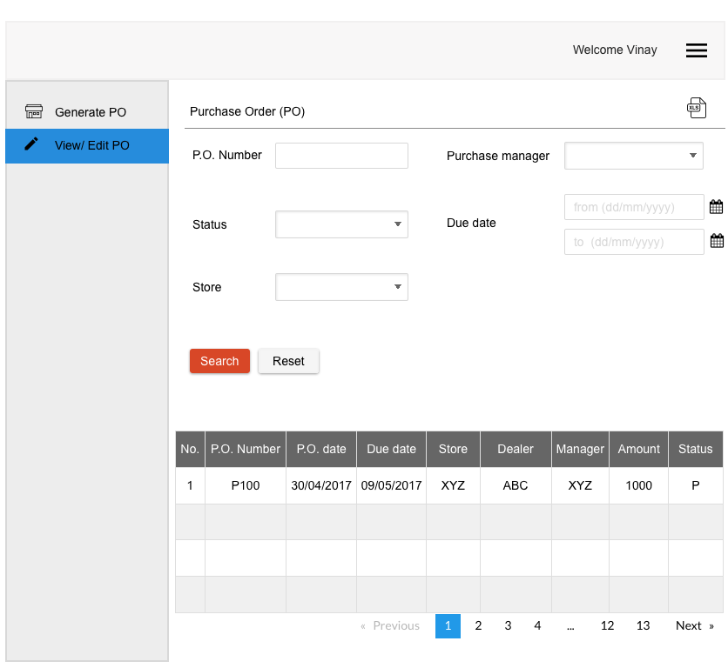

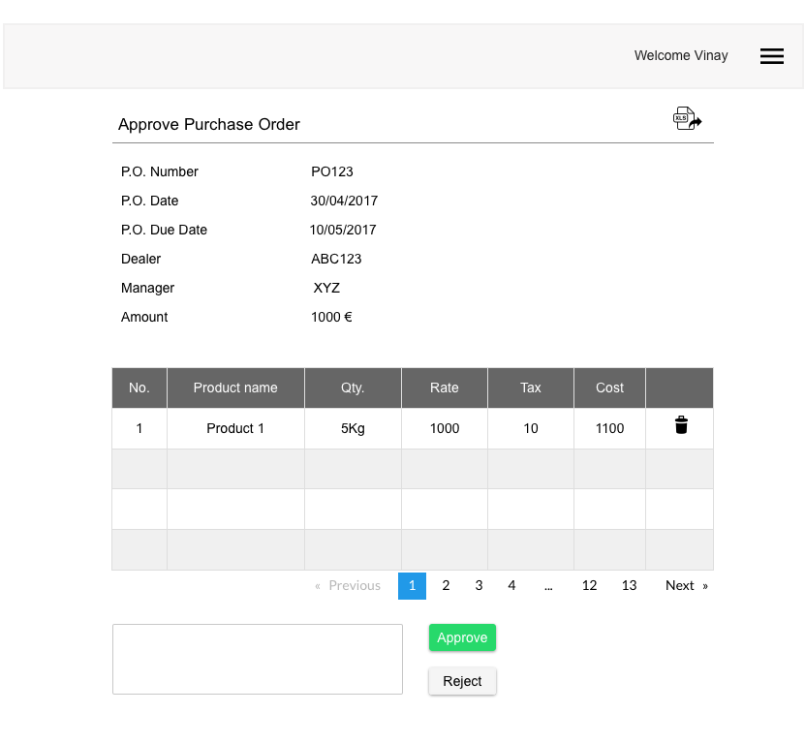

**GOODS RECEIVING DEPARTMENT SCREENS**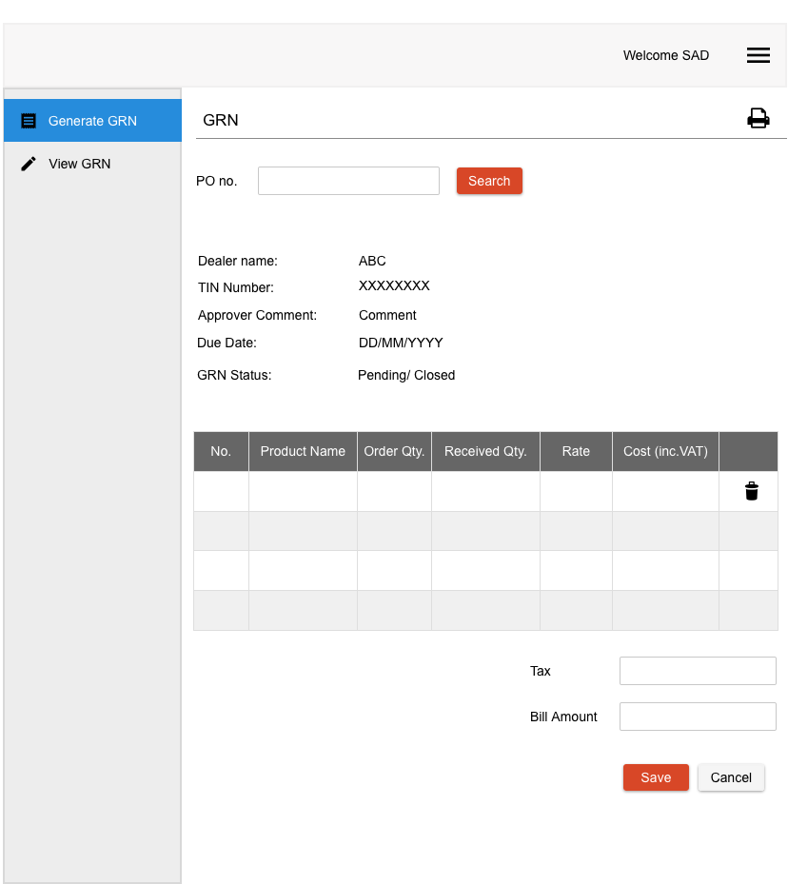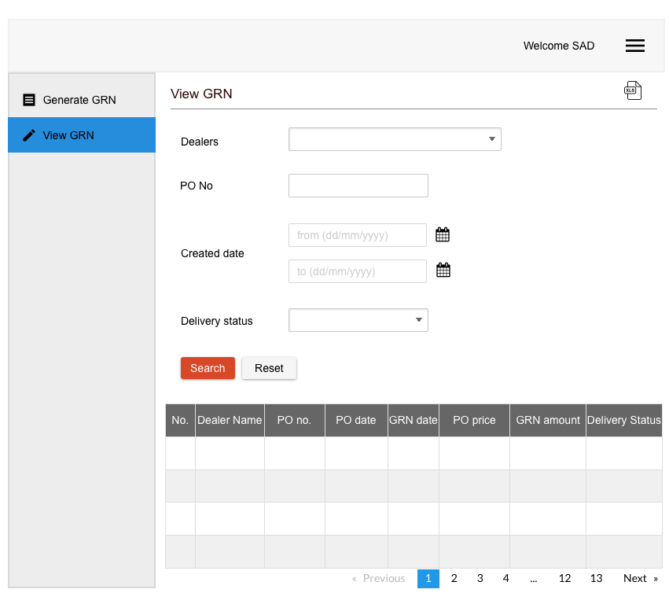

**BILLING DEPARTMENT SCREENS**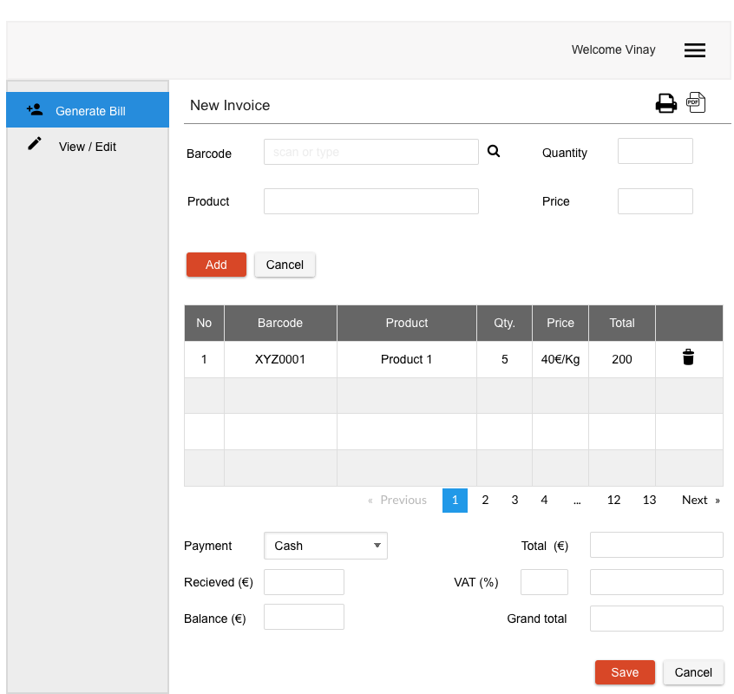

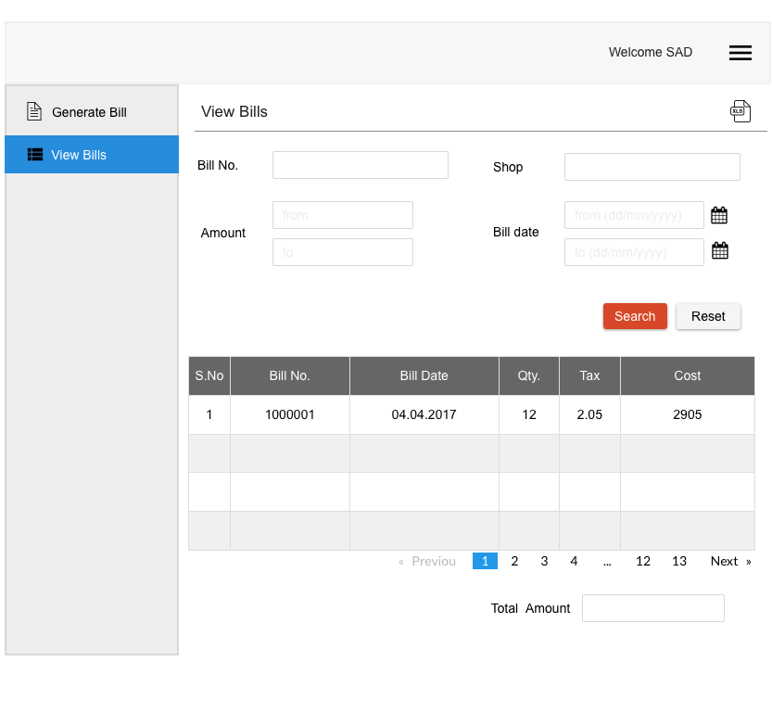

**STOCK REPORT SCREEN**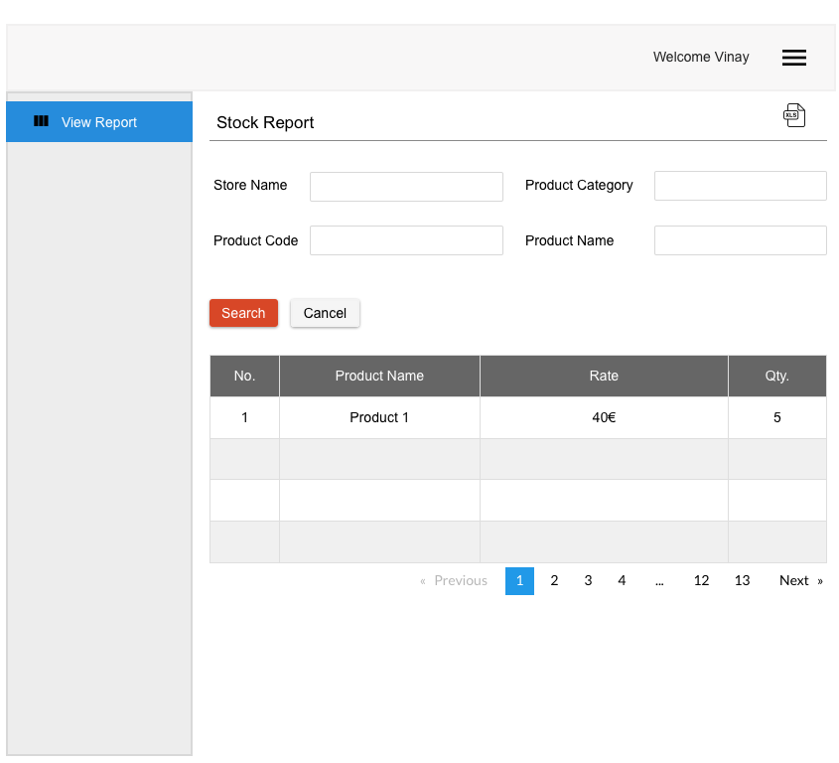

# TECHNOLOGY

Below are the technologies that will be used to implement the ERP application.

***Technology*:** Java J2EE 1.8, HTML5, CSS3, Angular JS4.

***Framework*:** Spring MVC design pattern.

***Database*:** Oracle 12c.

**TECHNICAL ARCHITECTURE**

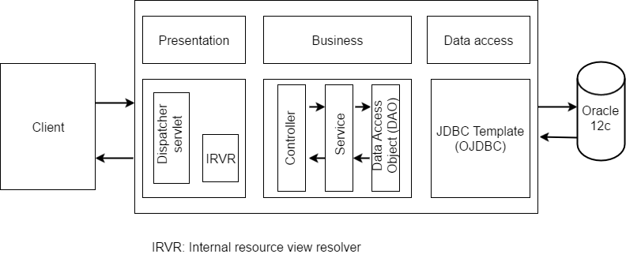

1. Java J2EE combined with Spring MVC design pattern is one of the better ways to come up with http REST coding. Some of the key features are as below

Dispatcher servlet - It is a design pattern that serves as the sole servlet implementation in servicing all the incoming http requests.

Internal resource view resolver – It’s a spring implementation which identifies the view example jsp, html etc. based on the http URL patterns.

1. Angular JS is a JavaScript based open source front end web application framework that supports MVC framework on the client side. Important feature of are as below

Decoupling of DOM elements from application logic.

Decoupling client side of an application from the server side.

1. Oracle 12c – Since, the application requires no compromise on consistency when it comes to CAP theorem and Oracle is one of the better Database Base in providing consistency. Oracle 12c will be used for the implementation. Being the latest of the Database release from Oracle, this serves the purpose of data storage.

# VISION AND MISSION

**VISION**

Our vision is to help Retail stores operate in a smart and efficient way.

**MISSION**

Our mission is to develop an ERP application that can act as a single platform for all the retail sectors and automate certain processes which can reduce manual effort.

# USER STORY TO TASK MAPPING

The below task map shows the task estimation to develop the application.

|  |  |  |  |  |
| --- | --- | --- | --- | --- |
| **ACTIVITIES** | **TASKS** | | | |
| **FRONT END (Screens)** | **MIDDLEWARE** | | **DATABASE** |
| **Login** | Login screen | 1)Login credentials  Validation and verification | Connection to  the database | Database queries  to select |
| **Administration** | Add User details | 1)Validation and  verification of the  user details | Connection to  the database | Database queries  to insert a user |
| View/ Edit users | 1)Validation and verification  of the requested  user details | Connection to  the database | Database query  to fetch/update the  user record |
| Display user details or Display user details/ details to edit | 1)Return result to the frontend |
| **Data Entry** | Add  Dealers/Products/ Shop details | 1)Validation and verification  of the details | Connection to the  database | Database queries  to insert a  Dealers/Products /Shop details |
| View/Edit  Dealers/Products /Shop details | 1)Validation and verification  of requested  Dealers/Products /Shop details | Connection to  the database | Database query  to fetch/update  corresponding record |
| Display Dealers/Products/Shop details or Display Dealers/Products/Shop details to edit | 1)Return result to the frontend |
| **Goods Receiving** | Generate GRN | 1)Validation and verification of GRN details 2)Business logic to add products to available stocks**(Automation)** | Connection to  the database | Database queries to insert generated GRN and to update the Delivery status |
| View GRN | 1)Validation and verification  of requested GRN details | Connection to the  database | Database queries to fetch GRN |
| Display GRN details | 1)Return result to the frontend |
| **Purchase Order  Management** | Create Purchase order | 1)Validation and verification  of the PO details | Connection to the  database | Database queries  to insert the  PO details |
| View/Edit PO | 1)Validation and verification  of requested  PO details | Connection to the  database | Database queries to fetch/update PO details |
| Display PO details Display PO details to edit | 1)Return result to the frontend |
| PO approval | 1)Validation and verification  of the PO details 2)Business logic to trigger email to Dealers**(Automation)** | Connection to the  database | Database query to update approval status |
| **Billing** | Generate bill | 1)Validation and verification of bill details 2)Business logic to update available stocks**(Automation)** | Connection to the  database | Database query to insert Billing details |
| View Bill | 1)Validation and verification of requested bill details | Connection to the  database | Database query to fetch details |
| Display bill details | 1)Return result to the frontend |
| **Reporting** | Generate report | 1)Validation and verification of requested stock details | Connection to the  database | Database query to fetch requested stock details |
| Display stock report | 1)Return result to the frontend |

# WORKLOAD DOCUMENTATION

The below table consists of the hours of meeting and the tasks accomplished after each meeting.

|  |  |  |  |
| --- | --- | --- | --- |
| **HOURS OF MEETING HELD** | **TASK** | **MEMBERS PRESENT IN MEETING** | **TASK RESPONSIBILITY** |
| **2** | Project topic discussion | Anusha, Vinay, Prabhu, Sachin, Manoj | Prabhu |
| **3** | use cases | Anusha, Vinay, Prabhu, Sachin, Manoj | Anusha, Vinay, Prabhu, Sachin, Manoj |
| **4** | Interviews | Anusha, Vinay, Prabhu, Sachin, Manoj | Prabhu,Anusha, Vinay, Sachin, Manoj |
| **3** | Interview analysis | Anusha, Vinay, Prabhu, Sachin, Manoj | Anusha, Vinay, Prabhu, Sachin, Manoj |
| Interview analysis reporting | Anusha, Vinay, Prabhu, Sachin, Manoj | Prabhu |
| Persona | Anusha, Vinay, Prabhu, Sachin, Manoj | Anusha |
| UXPin account and GIT repo setup | Anusha, Vinay, Prabhu, Sachin, Manoj | Vinay |
| **4** | Low fidelity prototype | Anusha, Vinay, Prabhu, Sachin, Manoj | Prabhu |
| **3** | Hi fidelity prototype(Iteration 1) | Anusha, Vinay, Prabhu, Sachin, Manoj | Vinay ,Anusha,Prabhu,Sachin,Manoj |
| **4** | Hi fidelity prototype interaction | Anusha, Vinay, Prabhu, Sachin, Manoj | Vinay, Anusha |
| **3** | Hi fidelity prototype user testing and feedback analysis | Anusha, Vinay, Prabhu, Sachin, Manoj | Sachin |
| Hi fidelity prototype response updates | Anusha, Vinay, Prabhu, Sachin, Manoj | Vinay, Anusha |
| **3** | Project Environmental setup | Anusha, Vinay, Prabhu, Sachin, Manoj | Vinay |
| **3** | Documentation | Anusha, Vinay, Prabhu, Sachin, Manoj | Anusha, Vinay, Prabhu, Sachin, Manoj |
| Documentation merge | Anusha, Vinay, Prabhu, Sachin, Manoj | Anusha |

# REFERENCES

[1] https://en.wikipedia.org/wiki/Retail

[2] https://www.thebalance.com/retail-store-organization-2890447